What is an atom?
Atoms are the “_____________________________” of matter.
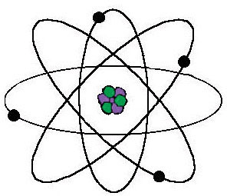
Atomic Structure/Location:
Nucleus: __________________________ & ____________________________
Electron cloud/orbit: __________________________________
Electrons
- Tiny, very light particles (do not count ________________)
- Have a _____________________electrical charge (-)
- Move around the outside of the nucleus
Protons
- Much larger and heavier than electrons
- Protons have a ________________ charge (+)
- Located in the nucleus of the atom
Neutrons
- Large and _________________ like protons
- Neutrons have __________ electrical charge
- Located in the nucleus of the atom
If all atoms are made of protons, neutrons, & electrons, why do different atoms have different chemical properties? ____________________________
- Electrons are the parts of atoms that are affected by ________________________________!
- Atoms of different elements have different numbers of electrons, protons, and neutrons!
Differentiating Atoms
Atomic Number= Number of protons in the nucleus-determines the type of atom
Since atoms are electrically ___________________, the # of protons = # of electrons
Mass Number = Number of protons + neutrons in the nucleus
Usually very close to the atomic mass BUT it’s ________ the same thing!
Protons + neutrons= mass
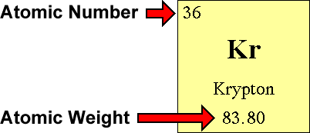
How to determine the number electrons, neutrons, & protons for an element? :
- Atomic # = # of ________________________- determines the atom
- Atomic mass = # of __________________ + ___________________
- In neutral atoms: #protons = electrons & many times neutrons
- To determine # of neutrons:
atomic _______________________ - # of __________________________

