Name: _________________________________ Block: _______ Date: __________
Collisions and Conservation of Momentum:

- In elastic collisions, the objects ______________ after colliding.
- In inelastic collisions, the objects ______________ after colliding.
- The law of conservation of momentum states that the total momentum before a collision is _____________________ the total momentum after a collision.

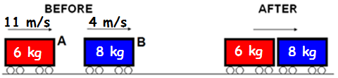
- The two carts above collide with one another and they stick together.
  - What type of collision is this?
  - What is the total momentum before the collision?
  - What is the total momentum after the collision?
  - What is the speed of the two stuck-together carts after the collision?

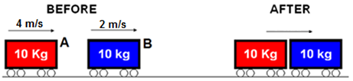
- The two carts above collide with one another and they stick together.
  - What type of collision is this?
  - What is the total momentum before the collision?
  - What is the total momentum after the collision?
  - What is the speed of the two stuck-together carts after the collision?

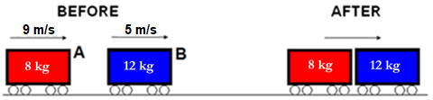
- The two carts above collide with one another and they stick together.
  - What type of collision is this?
  - What is the total momentum before the collision?
  - What is the total momentum after the collision?
  - What is the speed of the two carts after the collision?

