Name: __________________________________ Block: ______ Date: _________
Diagrams: KE, PE, TME, and the Conservation of Energy
- Kinetic energy is the energy of motion, and objects have more KE when they are moving.
- Potential energy is the energy of storage, and objects have more PE when they are stationary.
- Total mechanical energy is conserved in a closed system, which means that it is neither created nor destroyed, it just changes from one form to another.
- On the diagram below:
  - Find the point with the most potential energy and label it “most PE.”
  - Find the point with zero potential energy and label it “zero PE.”
  - Find the point with the most kinetic energy and label it “most KE.”
  - Find a part of the track where PE turns into KE and label it.
  - Find a part of the track where KE turns into PE and label it.
  - Finish labeling all the KE, PE, and TME values for the whole track.
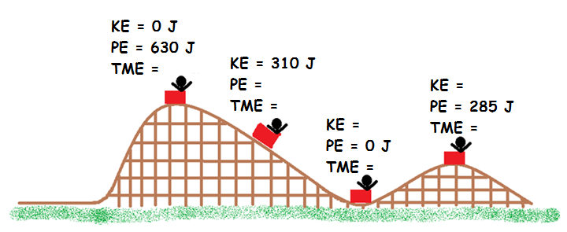
- On the diagram below:
  - Find the point with the most potential energy and label it “most PE.”
  - Find the point with zero potential energy and label it “zero PE.”
  - Find the point with the most kinetic energy and label it “most KE.”
  - Find a part of the track where PE turns into KE and label it.
  - Find a part of the track where KE turns into PE and label it.
  - Finish labeling all the KE, PE, and TME values for the whole track.
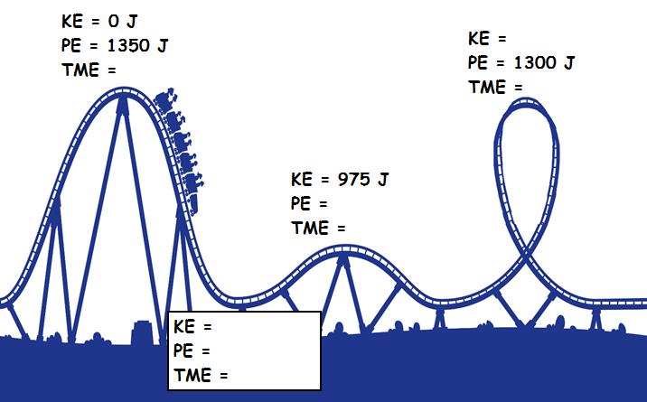

- Write TWO sentences to summarize KE, PE, TME, and the conservation of energy:

