The Total Mechanical Energy
The mechanical energy of an object can be the result of its motion (i.e., kinetic energy) and/or the result of its stored energy of position (i.e., potential energy). The total amount of mechanical energy is merely the sum of the potential energy and the kinetic energy. This sum is simply referred to as the total mechanical energy (abbreviated TME).
TME = PE + KE
As discussed earlier, there are two forms of potential energy discussed in our course - gravitational potential energy and elastic potential energy. Given this fact, the above equation can be rewritten:
The diagram below depicts the motion of Li Ping Phar (esteemed Chinese ski jumper) as she glides down the hill and makes one of her record-setting jumps.
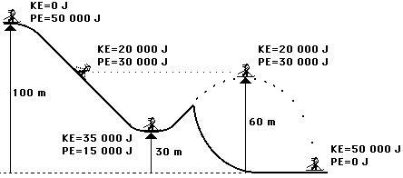
The total mechanical energy of Li Ping Phar is the sum of the potential and kinetic energies. The two forms of energy sum up to 50 000 Joules. Notice also that the total mechanical energy of Li Ping Phar is a constant value throughout her motion. There are conditions under which the total mechanical energy will be a constant value and conditions under which it will be a changing value. This is the subject of Lesson 2 - the work-energy relationship. For now, merely remember that total mechanical energy is the energy possessed by an object due to either its motion or its stored energy of position. The total amount of mechanical energy is merely the sum of these two forms of energy. And finally, an object with mechanical energy is able to do work on another object.

